RSHE/PSHE Plan – Respite

Due to the revolving door of respite provision, we have created a programme of 14 lessons which cover the 14 big ideas. These are the ideas that we feel every student should leave school having explored and will support them in being successful when returning to mainstream. For each of the big ideas we explore a range of questions for them to think about in the lesson. Due to the nature of the respite provision, students can enter this at any stage and we try to work on specific lessons that we feel the young person may need. There maybe changes/adaptations to the below to support key topic areas that may arise at the time.

Identity  What makes you unique?  What gives us our identity?  How can you identify with others? | Gender and sexuality  What is the difference between gender identity, gender expression, biological gender and sexuality?  Does gender or sexual preference matter?  Do you judge someone based on these factors? | Healthy relationships  Are their different types of relationship?  How can you recognise if a relationship is healthy or not?  What can you do to get support? | Risks  Can risks be both good and bad?  How do you judge if a risk is worth taking?  How do you protect yourself from unnecessary risk? | Bullying  Why do you think individuals bully others? What should be done to stop bullying? Do you know how to get support?
Mental health  What does mental health mean?  How do you look after your own wellbeing and mental health?  Do you know the warning signs that you need support? | Racism/Discrimination  What do you identify as racist? Does a persons’ race matter? Are you aware of the history of racism? | 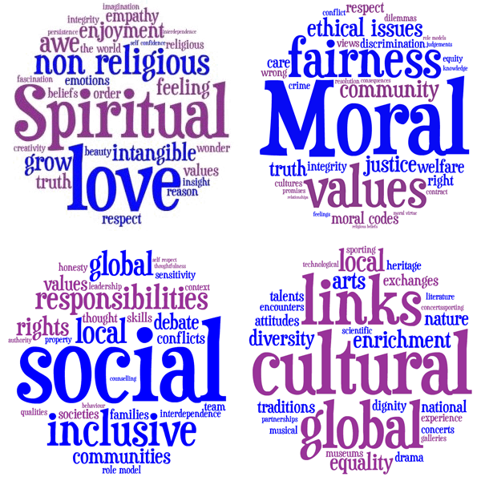 | Internet safety  Do you know the law around internet safety?  Do you know how to keep yourself safe online?  Do you know what information is online about you?  Mis and Disinformation | Rights  Do you know your rights as an individual? Do those rights come with responsibilities? Do you know how to protect your rights?
Sex and drugs  Do you know the law around sex and drugs? Do you know how to keep yourself safe? Do you know how to keep others safe? | Tolerance and respect  Is there a difference between tolerance and respect? Should someone have to earn your respect? Why should others respect you? | Cultural diversity  What does cultural diversity mean to you? What are the benefits of cultural diversity? What are the challenges to cultural diversity? | British Values  What does it mean to be British? Do you understand democracy and the rule of law? How do you engage with the democratic process? | Emotional literacy  Is it important to talk about your emotions? Can you recognise the emotions of others? How can you regulate your emotions and the consequent actions?

