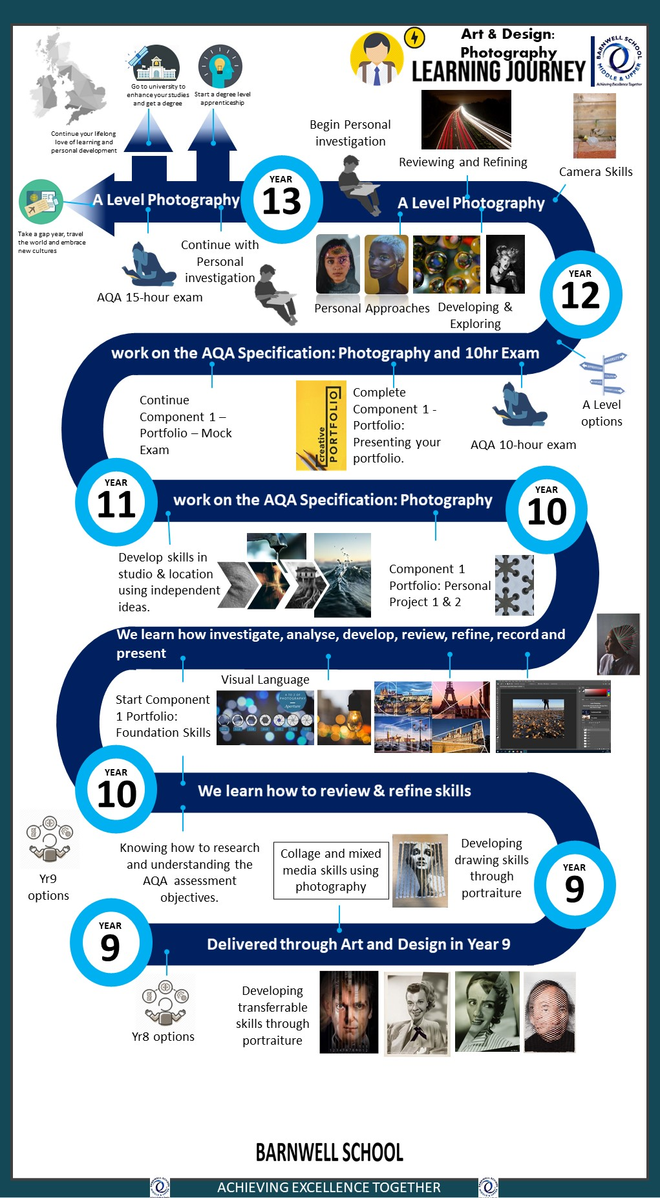

Still life, Pop art, natural form, landscapes, portraiture
Year 10
T1,2
Year 10
T3, 4
Year 10
T5, 6
Will Adams Academy
Art & Design learning journey

Year 10 T5,6
Term 1 -Year 11 bassline assessment
Tonal gradients, Printing skills, observational drawing, colour theory, 3D making
Bassline Assessement
Year 11
T1,2
Bassline assessment
We are learning foundation skills
[Grab your reader’s attention with a great quote from the document or use this space to emphasize a key point. To place this text box anywhere on the page, just drag it.]
Year 11
T3,4,5
Fine Art
Post 16
Post 16
Drawing & painting skills
Post 16 destinations
Fine Art
Post 16 destinations

